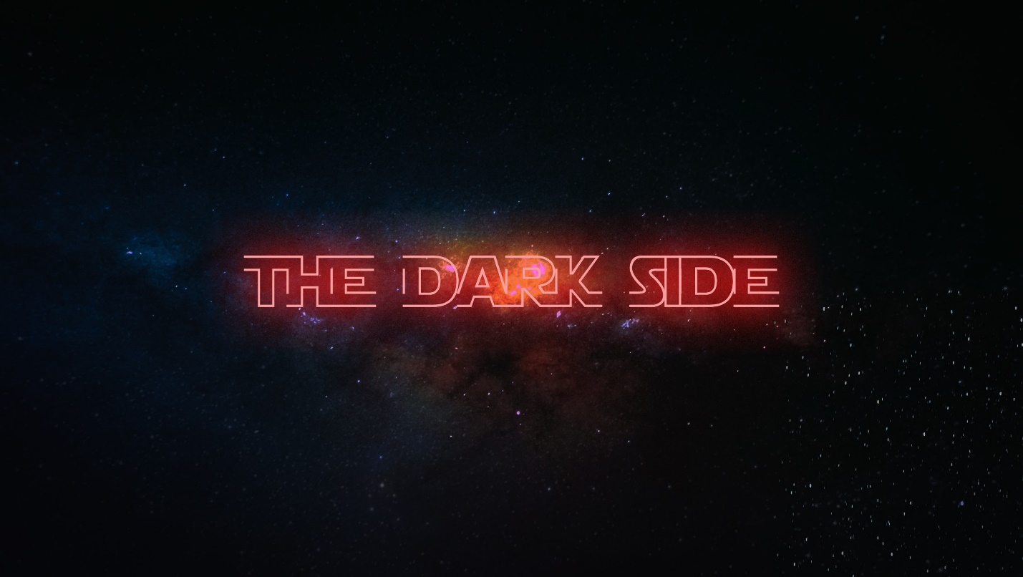

**Week 2 - The Dark Side**

**LIFE/INTRO QUESTIONS (CHOOSE 1 OR 2)**

* Are you ready for Christmas break?
* What fears have you experienced this week?

**CONNECTION QUESTION**

* Has fear of something ever ruined a season or time period in your life? How so?

**Sermon in a Sentence**

* God hasn’t given you a Spirit of Fear!

**SCRIPTURE**

* **2 Timothy 1:7** For God has not given us a spirit of fear, but of power and of love and of a sound mind.
* **Matthew 6:25-27** Therefore, I tell you, do not worry about your life, what you will eat or drink; or about your body, what you will wear. Is not life more than food, and the body more than clothes? 26 Look at the birds of the air; they do not sow or reap or store away in barns, and yet your heavenly Father feeds them. Are you not much more valuable than they? 27 Can any one of you by worrying add a single hour to your life?
* What is Jesus saying in these scriptures?

**DISCUSSION QUESTIONS**

* What are some things that you worry about on a day to day basis? Give some examples.
* Are you happier when you worry or don’t worry? Have you ever met a worry filled person that was happy and joyful?
* Do you believe that joy is not an emotion but a choice? Why or why not?

**LIFE APPLICATION**

* How can you connect to Jesus this week so that you may be joyful? Encourage the students that Jesus is the joy of our life and without Him we will not find true happiness and joy.

**TAKE IT OUT**

* Close small group out with prayer requests.
* Remind your students that RIGHT NOW is the best time to register for Fusion – they need to go to fusion.events tonight and lock in the super-low $49 price. The cost will increase in 4 DAYS on December 8th!
* Refuse to let money stand in the way – check FPSLeaders.com for a scholarship application if needed.